**Full Stack Web Development Project**

**INDUSTRIAL TRAINING REPORT**

Submitted in partial fulfillment of the

*Requirements for the award of the degree*

*of*

Bachelor of Technology

in

**Information Technology**

By:

**Abhay Raj**

**University Enrolment No.: 00976803122**

**IT – 3 (2022-2026)**



**Department of Information Technology**

**Guru Tegh Bahadur Institute of Technology**

**Guru Gobind Singh Indraprastha University**

**Dwarka,New Delhi**

**Year 2020-2024**



**Certificate**

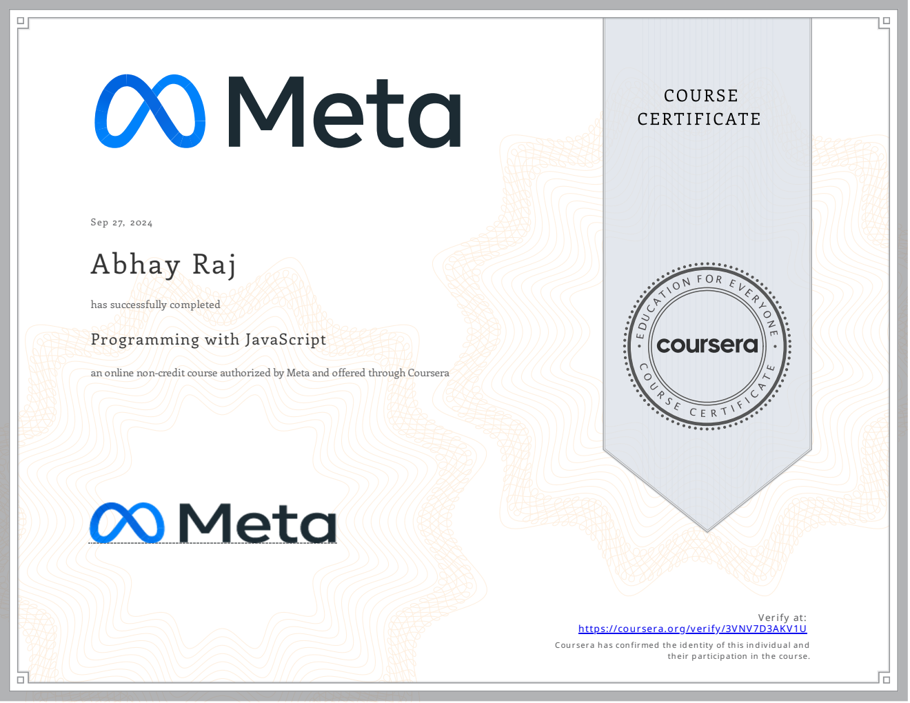

**Abstract**

This project report presents the development of **SocSpecs**, a full-stack web application built to enhance the user experience of social interaction by sharing and discovering new perspectives. SocSpecs enables users to create, share, and explore posts with a unique focus on user-generated content that reflects individual views on various topics. This application combines a modern, scalable, and performant tech stack: **JavaScript**, **Next.js**, **PostgreSQL**, and **Tailwind CSS**.

Next.js was selected as the primary framework for its flexibility and strong support for server-side rendering (SSR), allowing for fast load times and SEO-friendly pages. PostgreSQL serves as the relational database for handling persistent data storage, ensuring data integrity and security for user profiles, posts, likes, and comments. Tailwind CSS provides a utility-first approach to design, enabling a responsive and visually appealing user interface. JavaScript drives the core logic and dynamic behavior of the application, bridging the back-end with the front-end for a seamless user experience.

This report documents the design and development process, covering architecture, user interface, database structure, and functionality. It also discusses challenges faced during implementation and the solutions devised to overcome them. The outcome is a user-centered platform that offers a rich, interactive experience, fostering community engagement through a responsive and visually coherent interface.

**Table of Contents**

|  |  |  |
| --- | --- | --- |
| **S. No** | **Chapter** | **Page. No** |
|  | Title Page | i |
|  | Certificate | ii |
|  | Abstract | iii |
|  | Tables and figures | vi |
| **1** | **Introduction** | 1 |
| 1.1 | Background and Motivation |  |
| 1.2 | Purpose and Objectives |  |
| 1.3 | Scope of the Project |  |
| 1.4 | Technology Stack |  |
| 1.5 | Challenges and Considerations |  |
| 1.6 | Who Can Benefit from SocSpecs? |  |
| **2** | **Requirement Analysis (SRS)** |  |
| 2.1 | Purpose | 7 |
| 2.2 | Scope |  |
| 2.3 | Functional Requirements |  |
| 2.4 | Non-Functional Requirements |  |
| 2.5 | System Design Constraints |  |
| 2.6 | Assumptions and Dependencies |  |
| **3** | **System Design** | 10 |
| 3.1 | Client-Server Architecture |  |
| 3.2 | Entity-Relationship (ER) Diagram |  |
| 3.3 | Data Flow Diagram (DFD) |  |
| 3.4 | Database Schema |  |
| **4** | **Body of Thesis** | 17 |
| 4.1 | Frontend Development |  |
| 4.2 | Backend Development |  |
| 4.3 | Database Structure and Optimization |  |
| 4.4 | System Architecture |  |
| 4.5 | Data Visualization and Comparison Mechanisms |  |
| 4.6 | Challenges and Solutions |  |
| 4.7 | Testing and Quality Assurance |  |
| 4.8 | Security and Data Protection |  |
| **5.** | **Screenshots and UI Walkthrough** | 22 |
| 5.1 | Landing Page |  |
| 5.2 | Ranking Page |  |
| 5.3 | Processor Details Page |  |
| 5.4 | Compare Page |  |
| 5.5 | Static Sidebar Navigation |  |
| 5.6 | Screenshots of Desktop and Mobile Views |  |
| **6.** | **Results and Observations** | 31 |
| 6.1 | Overview of System Functionality |  |
| 6.2 | System Testing Results |  |
| 6.3 | Observations |  |
| 6.4 | Challenges and Limitations |  |
| **7** | **Summary, Conclusions, and Future Scope** | 36 |
| 7.1 | Summary |  |
| 7.2 | Conclusions |  |
| 7.3 | Future Scope |  |
| **8** | **Appendices** | 41 |
| 8.1 | Appendix A: Source Code |  |
| 8.2 | Appendix B: Database Queries |  |
| 8.3 | Appendix C: Wireframes |  |
| 8.4 | Appendix D: User Feedback |  |
| 8.5 | Appendix E: Reference |  |

**LIST OF FIGURES AND TABLES**

|  |  |  |
| --- | --- | --- |
| **Fig No** | **Figure Name** | **Page** |
| 1. | Entity-Relationship (ER) Diagram |  |
| 2. | Data Flow Diagram (DFD) |  |
| 3. | Desktop View: Landing Page: |  |
| 4. | Desktop View: Processor Details: |  |
| 5. | Desktop View: Ranking Page: |  |
| 6. | Mobile View: Landing Page |  |
| 7. | Mobile View: Processor Details |  |
| 8. | Mobile View: Ranking Page: |  |

|  |  |  |
| --- | --- | --- |
| **Fig No** | **Table Name** | **Page** |
| 1. | Rankings Table |  |